Sayreville CAP January 14, 2009 meeting
DuPont

Welcome 6:00 PM

Dave Steward welcomed us to the plant.

Attendance

INDUSTRY | CORE CAP MEMBERS | NEW COMMUNITY
Jeff Staniszewski  Dave Steward  Paul Tuck  Sam Poku  Stan Pilch (absent) | Dawn Cannon (absent)  Don Curran  Donna Flores  Ray Garnett  Charlene Gerleit  Maryann Gordon  Ron Green (absent)  Eloise Hanson (absent)  Mary Ivan  Mary Kelly (absent)  Dorothy Magee  Ron Magee  Kathleen Makowski (absent)  Michelle Murphy  Ken Olchalskey (absent)  Joann Polgar (absent)  Joe Polgar (absent)  Robert Redford  Dolores Suminski  Mark Wolfthal | Madison Park guests:  Damaris Bermeo (absent)  Carlos Bermeo (absent)  Thomas Farbaniec (absent)  Antonio Masionet (absent)

Minutes from the October 15, 2008 meeting were accepted as written.

DuPont Update
Dave Steward:
- On December 4, 2008 DuPont announced a restructuring – eliminating approximately 2,000 employees and 4,000 contractors. The Parlin plan was not affected by this.
- There has been a cutback on expenditures as per administrative orders – watch overtime, etc.
- Approximately $2 billion that was spent on improvements has been cut back.
- December 30 completed donation of the land to the borough to be used as Green Space (trails)
- Additional groundwater remediation is in the near future.
- DuPont Parlin may still be hiring 10-14 employees.
- CYREL is operating at approx. 90%.
- Teflon is doing well, but flexible circuitry is slow.
- Joint venture with Hitachi is still working and there is some slow down.
Jeff:
- MCRESC school might start up in September 2009.
- Wildlife Certification has been renewed for the Wildlife Habitat on the property.

Hercules Update
Paul Tuck:
- The plant has had some break-ins stealing the copper from abandoned buildings.
- Hercules was without a reportable injury for 2008
- They have hired some employees in the past quarter.
- 3 HEC plants (one of them is Parlin) may be cutting back
- December 3, 2008 Planning Board approved Hercules to sell the parcel of land and Hercules does have a buyer.
- Ashland deal closed November 13, 2008 to buy Hercules. They have very little capital to use at this time.
- Ashland has facilities in Kearney, Carteret, and a few other local plants.
Sam Poku:
- Gave an update on the remediation of the brook by Jernee Mill Road. Brook 3 issue with tidal concerns – there are plans to have the cleanup of the DDT contamination finished by the end of January 2009

Other business
  - Paul Tuck came to Applegarth Middle School, Monroe Twp. for their Career Day
  - DuPont used grant money to donate more jackets to the Sayreville First Aid Squad
  - CAP members were given recognition for their volunteer work to the Sayreville CAP.

Meeting dates:

Wednesday, March 11, 2009 6:00 PM DuPont Cheesequake Road Gatehouse

Adjourn

Sayreville CAP January 14, 2009 minutes
submitted by Michelle Murphy

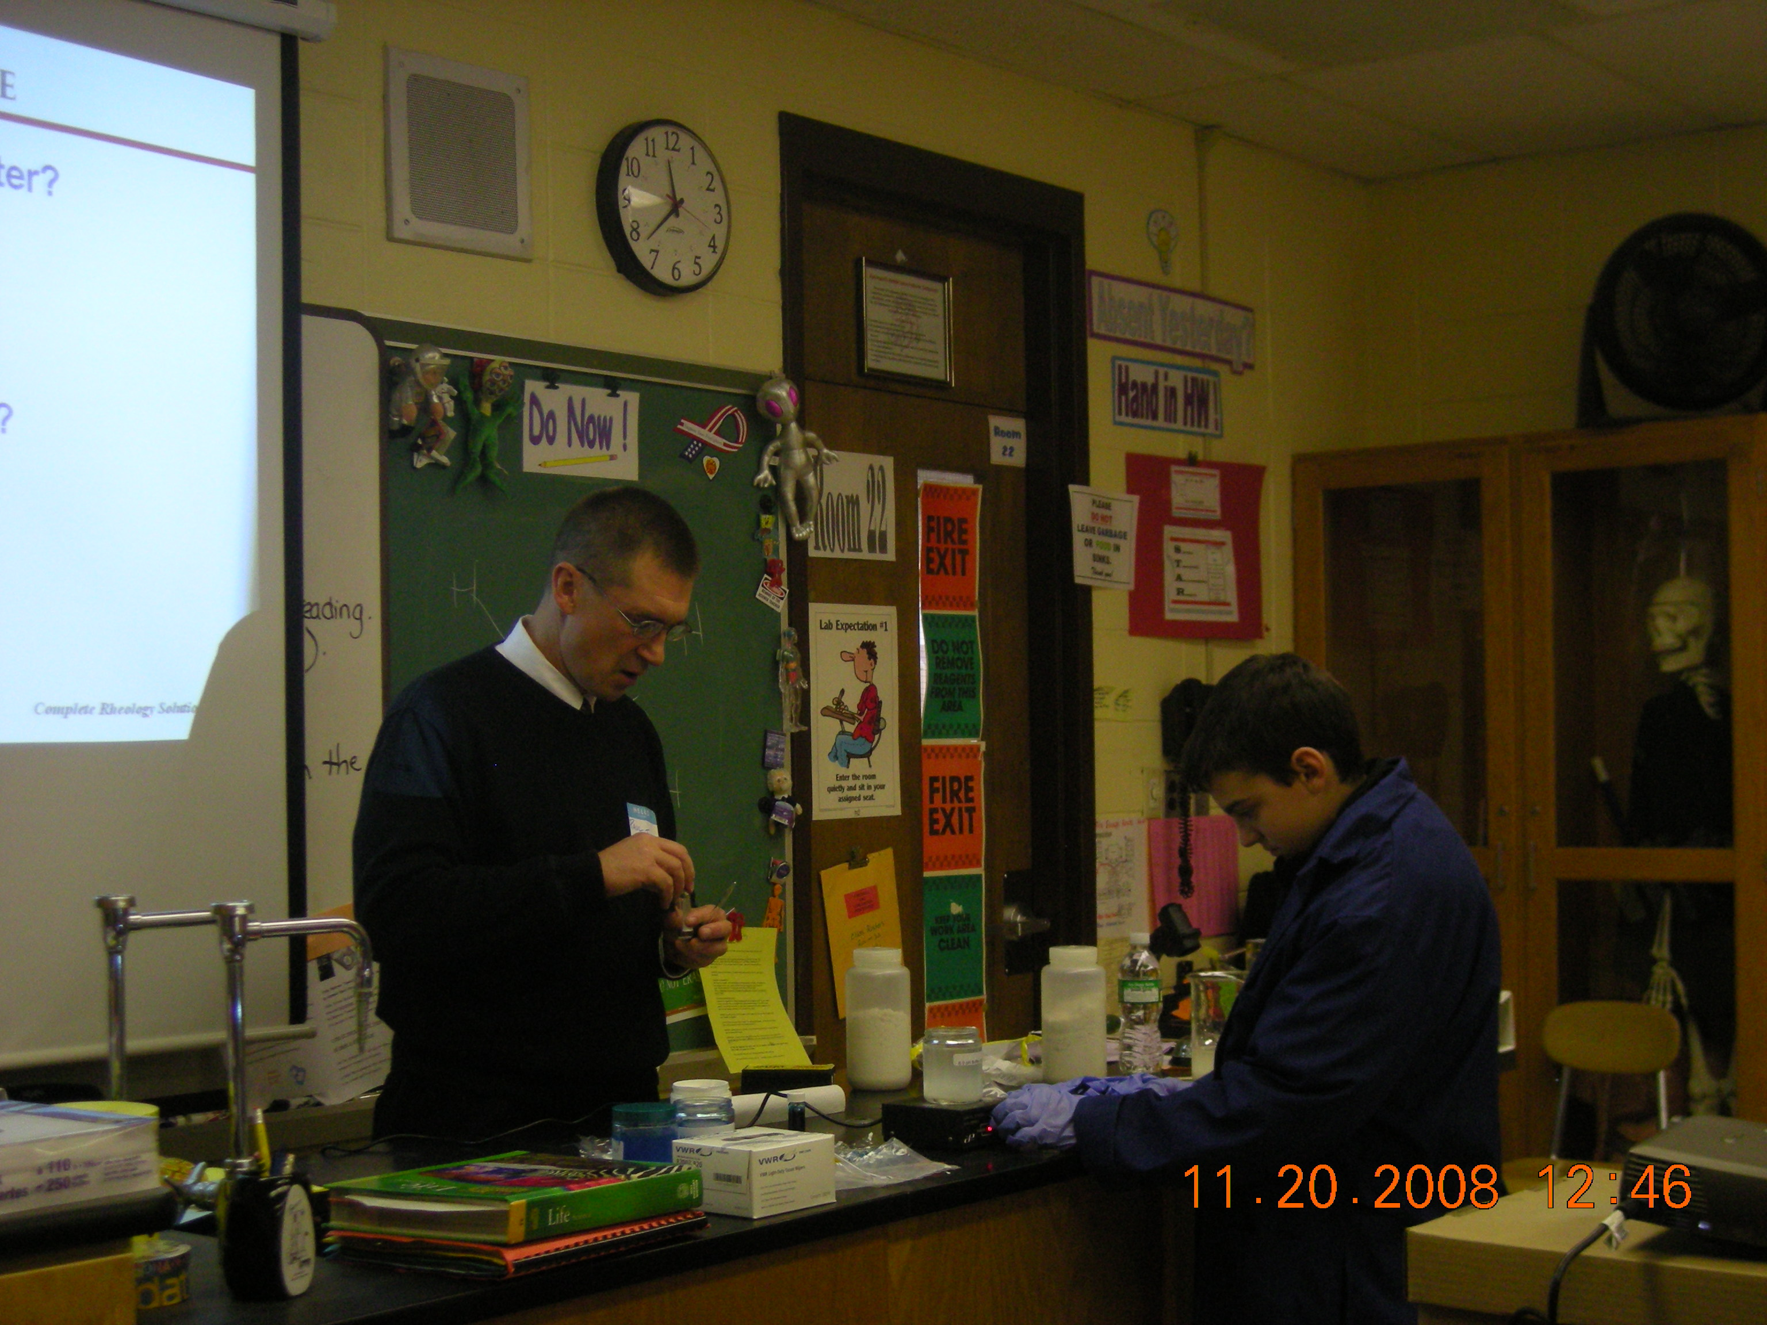
Paul Tuck at Applegarth Career Day 2008



